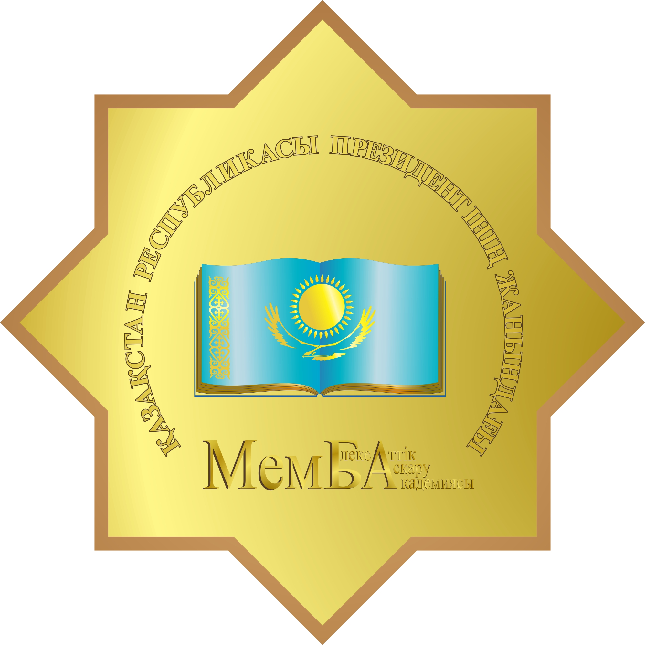

Registration Form
2017 AAPA Annual Conference
13-14 April in Astana, Kazakhstan

The following information will be used to identify your personal details, professional experience, as well as to contact you. Please enter your personal data correctly.
The registration fees is as follows: Students - 100 USD. Non-students - 150 USD.
The registration fee (inclusive of $50-membership fee for AAPA) will be accepted on site in cash in USD on the 3rd floor of the registration desk on 13 April from 9 am- 10 am and on 14 April from 09.30 am-10 am.

№ | Information about the employer/ organization:
1. | Type of organization: | International governmental organizations (NGOs) ___  The state, a parliamentary  Research ___  Other ___
2. | Country:
3. | Name of the organization:
4. | Position/title:
5. | Business address (with postal/zip code):
6. | Website:

№ | Your personal and passport details:
7. | Name/Surname (Full/ in English):
8. | Home address:  Full Address (in English)
9. | Cell phone: / Home telephone:
10. | Email:

11. Your ACCOMMODATION

I have already booked the room by myself ____ (Yes/ No)  I have already booked the room by  contacting Mr. Olzhas Bayanov (ACSH, UNDP)___ (Yes/ No) | Please indicate where do you plan to stay:  _____ Astana Marriott Hotel  _____ Park Inn by Radisson Astana  _____ Hotel Kazzhol Astana  _____ other hotel (please indicate) _____________________

№ | Personal flight details:  Please indicate the flight details (tickets/ booked one)
12. | Departure (From) country of origin (city):  ____________________________  Flight #:___________ | Arrival (to) country Kazakhstan (city):  _____________________  Flight #:___________
13. | Departure from Kazakhstan time and date:__________  Flight #:___________ | Arrival time and date in home country: ___________  Flight #:_____________

14. | Transportation
In a case if you have booked the hotel by yourself, please contact with the Hotel guest relations services to book a taxi to/from airport meeting.

Taxi is the recommended mode of transportation to/from airport and for travelling around the city. Average taxi fare is 700-1500 KZT (3-5 USD).

These are the recommended taxi companies:

1) " Saryarka Taxi"  Tel.: + +7 (7172) 34-11-11  Mobile: +7 (701) 534-11-11  Mobile: +7 (747) 534-11-11  Mobile: +7 (705) 534-11-11 |  | 2) “ЭКО Taxi” taxi  Tel.: +7(727)3 900 500  Mobile: +7(777)672 7777

During the event, the conference organizers will provide presenters with meals. All participants are responsible for their own international/local airfares, accommodation, and other travel costs.

The completed form can be submitted to Ms. Diana Sharipova at diana.sharipova@undp.org

